Jacob Keogh n9216111

Portfolio for Release 2

**Overview**

* Rapid prototyping in the early stages of logo design.
* Design of UI
* User Testing with wireframes for the UI
* Regular automated and manual selenium tests on the site to maintain functionality.
* Testing of the final system after Release 2, to ensure it met the acceptance criteria.
* Implementation of the UI is planned for Release 3 (too much time was spent trying to learn Bootstrap and CSS and we maintained a heavy focus on functionality in the release)

**Logo Design –** Only worked on the rapid prototyping in the early stages.

Example:

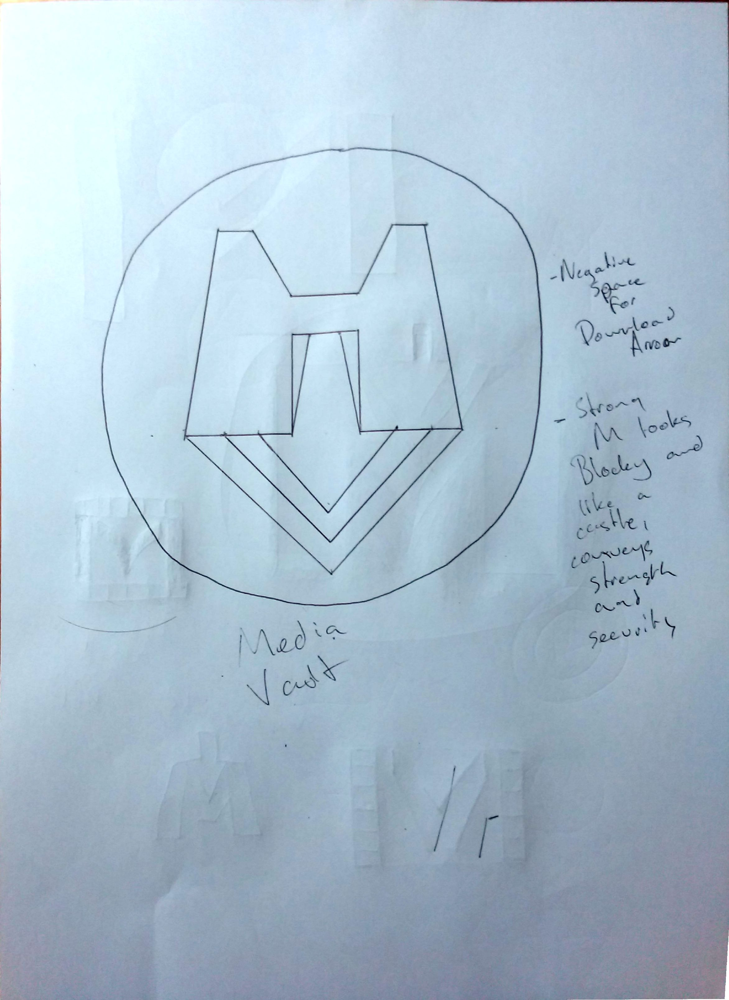

Rapid Prototype of ‘Media Vault’ Logo.

Simple hand drawn to express the idea.

Idea:

* Using negative space between an M and V to create a download arrow.
* Block letters to convey strength/security. M is meant to look like a fortress.

Feedback:

* Rejected; too confusing, does not clearly express the sites name or purpose.
* The fortress M could be more effective on its own.

**UI Design –** Only wireframe at this stage at it was still in testing to determine structure of the pages. Not implemented in Release 2.

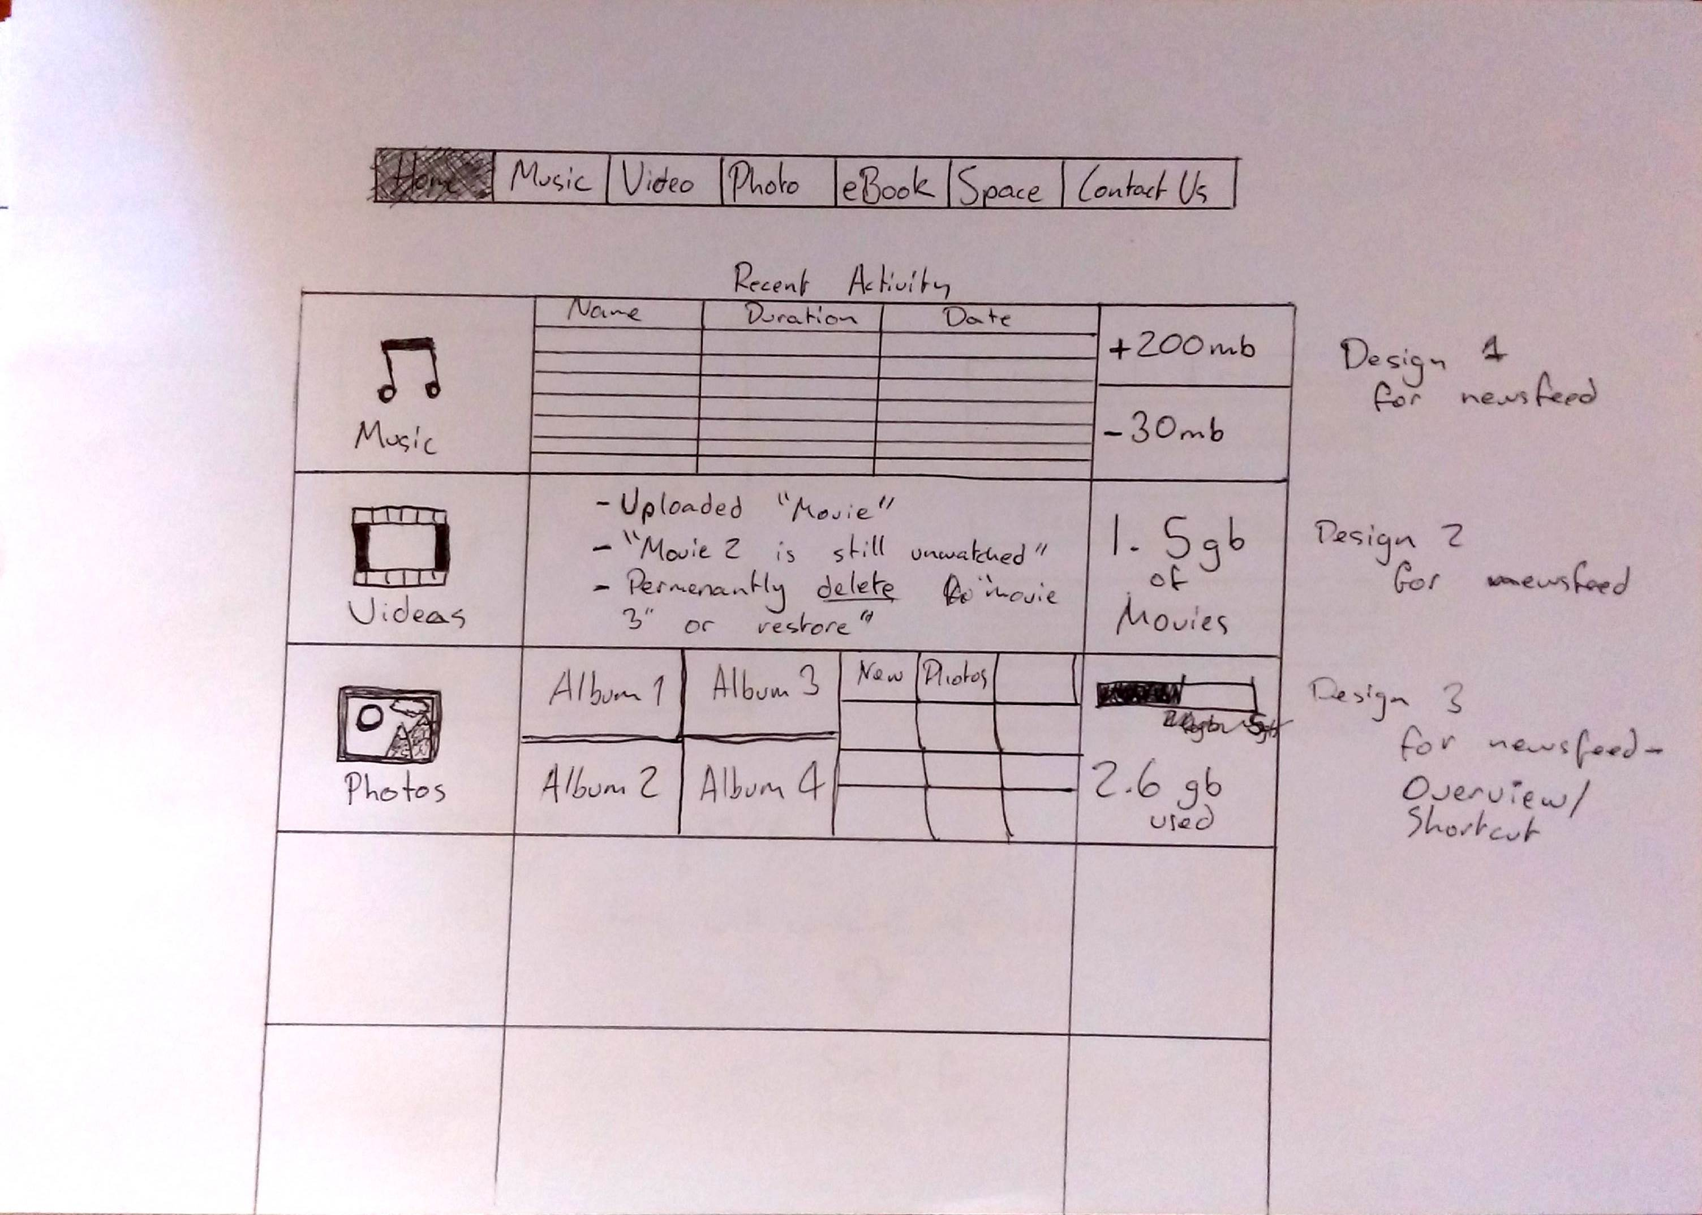

Design 1

Design 2

Design 3

For the newsfeed page of the UI design, multiple structures were made so that when tested people could be asked to compare them and the most popular could be used. However, when tested it seemed to be a personal preference, as all were chosen fairly equally. Ideally the users would be able to pick for themselves in their account options.

**Testing**

See “Release2testing” for the list ad results of the final test done for Release 2. Tests were done to see if the new additions to the site met the acceptance criteria.

As well as this weekly tests were done with the selenium suite made is Release 1, to ensure that all previous sections of the site remain functional while it is being updated.

Note: The testing suite was run every Sunday during release 2, at no point were the old features operational so no corrective measures were needed.

Summary of Results from Release 2 testing: